10 Linux Commands
View mounted filesystems.
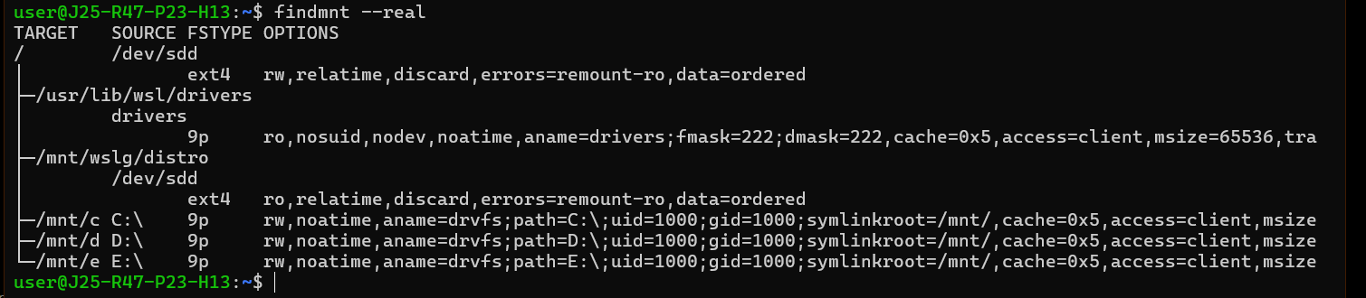

Inspect file access-control permissions.
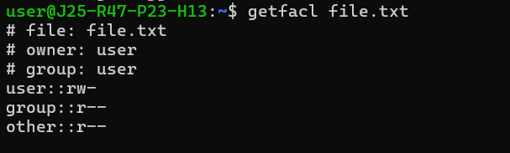

Grant your user read access to a test file.
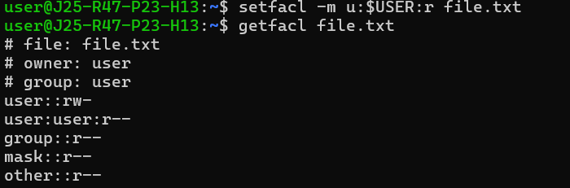

Run a process with idle I/O priority.
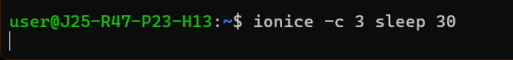

Run a process with a lower CPU scheduling priority.

Display resource limits for your current shell
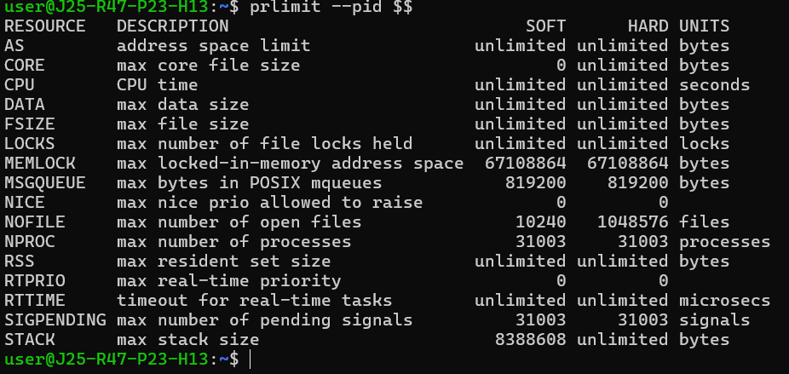

Display SELinux labels, if SELinux labeling is supported.
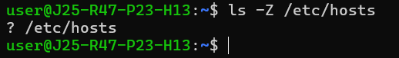

Run a temporary user-level systemd task, if your session supports it.
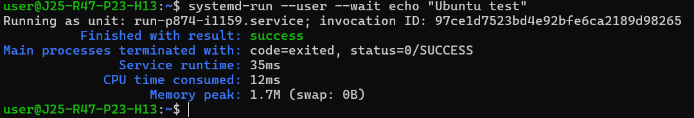

List services managed by your user-level systemd instance.
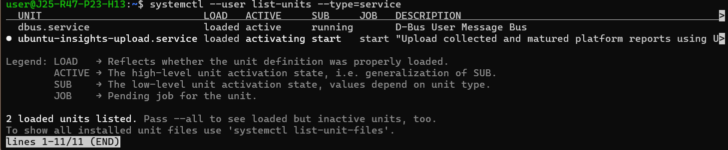

List recorded application crashes, if systemd-coredump is configured.
